Codealpha tasks for internship

Java development by Ayesha siddiqua ansari

**Task 1**

**Code:**

import java.util.Scanner;

public class StudentGradesWithArray {

public static void main(String[] args) {

Scanner scanner = new Scanner(System.in);

System.out.print("Enter the number of students: ");

int numStudents = scanner.nextInt();

double[] grades = new double[numStudents];

System.out.println("Enter the grades for each student:");

for (int i = 0; i < numStudents; i++) {

System.out.print("Grade for student " + (i + 1) + ": ");

grades[i] = scanner.nextDouble();

}

double sum = 0;

double highest = grades[0];

double lowest = grades[0];

for (int i = 0; i < numStudents; i++) {

sum += grades[i];

if (grades[i] > highest) {

highest = grades[i];

}

if (grades[i] < lowest) {

lowest = grades[i];

}

}

double average = sum / numStudents;

System.out.printf("Average score: %.2f%n", average);

System.out.printf("Highest score: %.2f%n", highest);

System.out.printf("Lowest score: %.2f%n", lowest);

scanner.close();

}

}

**Output:**

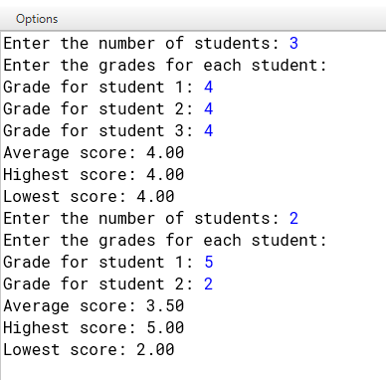

**TASK 2:**

**Code:**

import java.util.Scanner;

public class SimpleBankingApplication {

private static double balance = 0;

public static void main(String[] args) {

Scanner scanner = new Scanner(System.in);

while (true) {

System.out.println("\nWelcome to Simple Banking Application");

System.out.println("1. Check Balance");

System.out.println("2. Deposit");

System.out.println("3. Withdraw");

System.out.println("4. Exit");

System.out.print("Choose an option: ");

int choice = scanner.nextInt();

switch (choice) {

case 1:

checkBalance();

break;

case 2:

deposit(scanner);

break;

case 3:

withdraw(scanner);

break;

case 4:

System.out.println("Thank you for using the banking application. Goodbye!");

scanner.close();

System.exit(0);

default:

System.out.println("Invalid option. Please choose a valid option.");

}

}

}

private static void checkBalance() {

System.out.printf("Your current balance is: $%.2f%n", balance);

}

private static void deposit(Scanner scanner) {

System.out.print("Enter the amount to deposit: ");

double amount = scanner.nextDouble();

if (amount > 0) {

balance += amount;

System.out.printf("$%.2f has been deposited to your account.%n", amount);

} else {

System.out.println("Deposit amount must be greater than zero.");

}

}

private static void withdraw(Scanner scanner) {

System.out.print("Enter the amount to withdraw: ");

double amount = scanner.nextDouble();

if (amount > 0 && amount <= balance) {

balance -= amount;

System.out.printf("$%.2f has been withdrawn from your account.%n", amount);

} else if (amount > balance) {

System.out.println("Insufficient balance. Unable to withdraw.");

} else {

System.out.println("Withdrawal amount must be greater than zero.");

}

}}

**Output:**

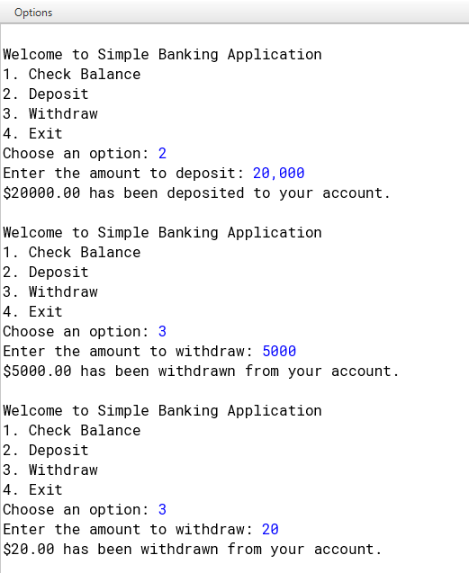

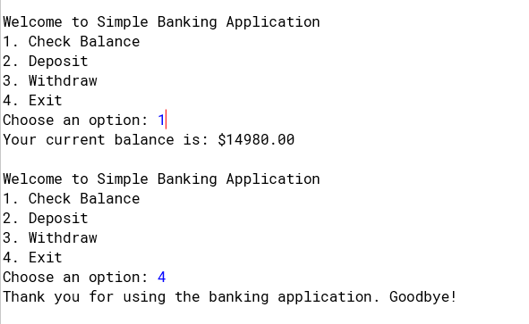

**Task 3:**

**Code:**

import java.util.ArrayList;

import java.util.Scanner;

class Room {

private int roomNumber;

private String roomType;

private double price;

private boolean isAvailable;

public Room(int roomNumber, String roomType, double price) {

this.roomNumber = roomNumber;

this.roomType = roomType;

this.price = price;

this.isAvailable = true;

}

public int getRoomNumber() {

return roomNumber;

}

public String getRoomType() {

return roomType;

}

public double getPrice() {

return price;

}

public boolean isAvailable() {

return isAvailable;

}

public void setAvailable(boolean available) {

isAvailable = available;

}

public String getRoomDetails() {

return "Room " + roomNumber + " - Type: " + roomType + ", Price: $" + price + ", Available: " + isAvailable;

}

}

class HotelReservationSystem {

private ArrayList<Room> rooms;

private ArrayList<String> reservations;

public HotelReservationSystem() {

rooms = new ArrayList<>();

reservations = new ArrayList<>();

initializeRooms();

}

private void initializeRooms() {

rooms.add(new Room(101, "Single", 100.00));

rooms.add(new Room(102, "Double", 150.00));

rooms.add(new Room(103, "Suite", 300.00));

rooms.add(new Room(104, "Single", 100.00));

rooms.add(new Room(105, "Double", 150.00));

}

public void displayAvailableRooms() {

System.out.println("\nAvailable Rooms:");

for (Room room : rooms) {

if (room.isAvailable()) {

System.out.println(room.getRoomDetails());

}

}

}

public Room searchRoom(int roomNumber) {

for (Room room : rooms) {

if (room.getRoomNumber() == roomNumber) {

return room;

}

}

return null;

}

public void makeReservation(int roomNumber, String customerName) {

Room room = searchRoom(roomNumber);

if (room != null && room.isAvailable()) {

room.setAvailable(false);

String reservation = "Room " + roomNumber + " reserved by " + customerName + " - $" + room.getPrice();

reservations.add(reservation);

System.out.println("Reservation successful! Payment of $" + room.getPrice() + " processed.");

} else {

System.out.println("Room is not available or does not exist.");

}

}

public void viewReservations() {

System.out.println("\nReservations:");

if (reservations.isEmpty()) {

System.out.println("No reservations have been made.");

} else {

for (String reservation : reservations) {

System.out.println(reservation);

}

}

}

}

public class Main {

public static void main(String[] args) {

Scanner scanner = new Scanner(System.in);

HotelReservationSystem hotel = new HotelReservationSystem();

while (true) {

System.out.println("\nWelcome to the Hotel Reservation System");

System.out.println("1. View Available Rooms");

System.out.println("2. Make a Reservation");

System.out.println("3. View Reservations");

System.out.println("4. Exit");

System.out.print("Choose an option: ");

int choice = scanner.nextInt();

switch (choice) {

case 1:

hotel.displayAvailableRooms();

break;

case 2:

System.out.print("Enter room number to reserve: ");

int roomNumber = scanner.nextInt();

scanner.nextLine();

System.out.print("Enter your name: ");

String customerName = scanner.nextLine();

hotel.makeReservation(roomNumber, customerName);

break;

case 3:

hotel.viewReservations();

break;

case 4:

System.out.println("Thank you for using the Hotel Reservation System. Goodbye!");

scanner.close();

System.exit(0);

break;

default:

System.out.println("Invalid option. Please try again.");

}

}

}

}

**Output:**

